**Data Exploration and Visualization**

Conducted by: Dr. Abhishek Agarwal

Date: 30-March-2021

**Home Task 3**

Amir Ali

**Question 1:**

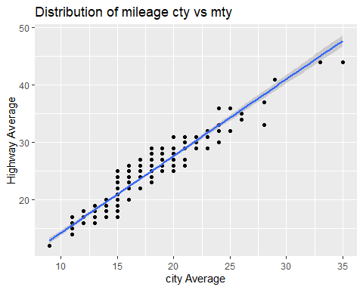

I have fitted a regression line to see the relationship between cty and hwy, it is clear that average cty is lesser than average hwy. Which proves the fact that on average car travel more distance on hwy and cty with same amount of fuel consumed.

**Question 2:**

**# A**

ggplot(mpg, aes(cty, hwy)) + geom_point()

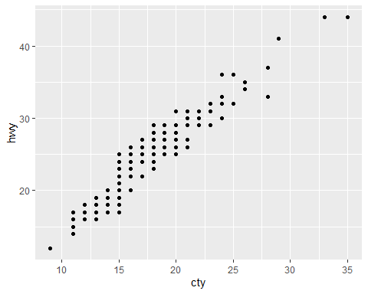

Plot shows the relation between cty and hwy for each car in the dataset, the color is black because there is no color specified and layer is point.

Dataset is mpg and the used cols are cty for x-axis and hwy for y-axis.

**# B**

ggplot(diamonds, aes(carat, price)) + geom_point()

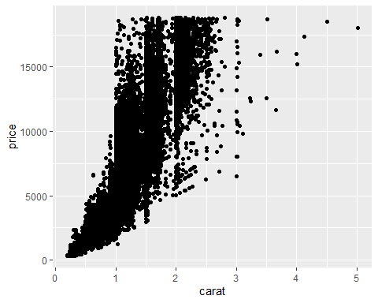

Dataset used is diamond which comes by default with ggplot2 cran package; the graph shows the relationship between carat and price of diamond, it is

Black by default as we have not specified any color, layer is point.

**# C**

ggplot(economics, aes(date, unemploy)) + geom_line()

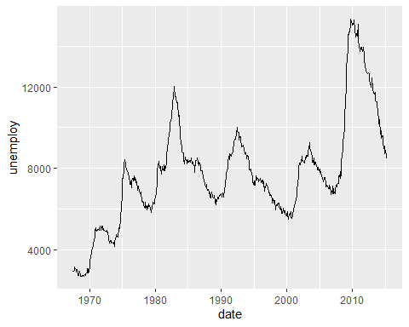

Dataset we are using is economic, again there is no color specified and the layer is line.

We are plotting unemployment rate given time.

# D

ggplot(mpg, aes(cty)) + geom_histogram()

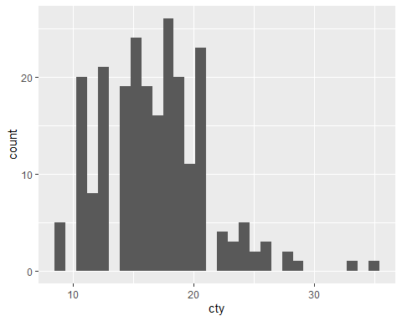

Have used mpg dataset, we have plotted a histogram for city average and there is non fill so the output is black.